**ENTERPRISE PROGRAMMING INSEM-1 exam**

**2100031921**

**E.kowshik**

**XML DOM (prepare menu card)**

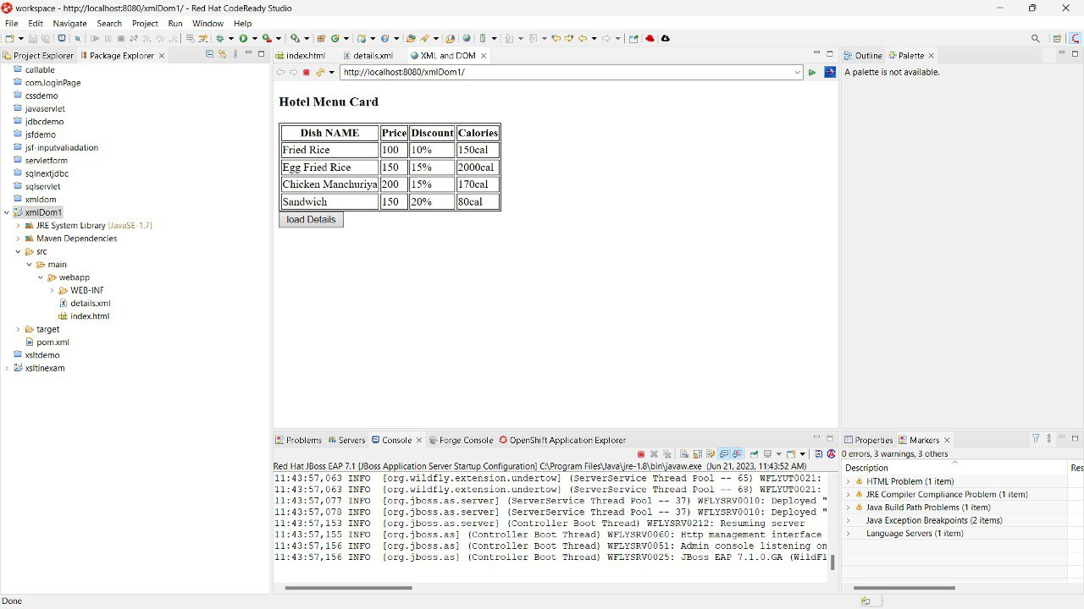

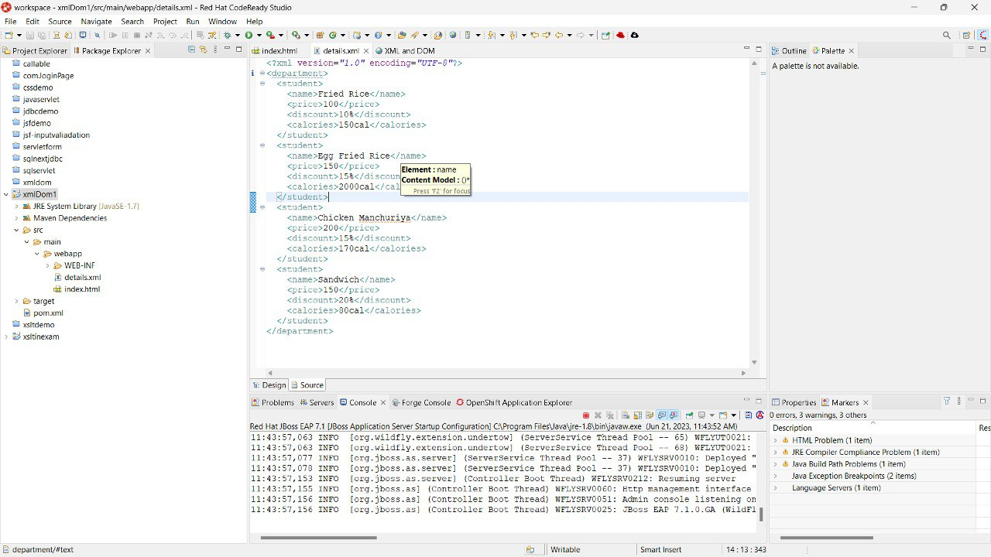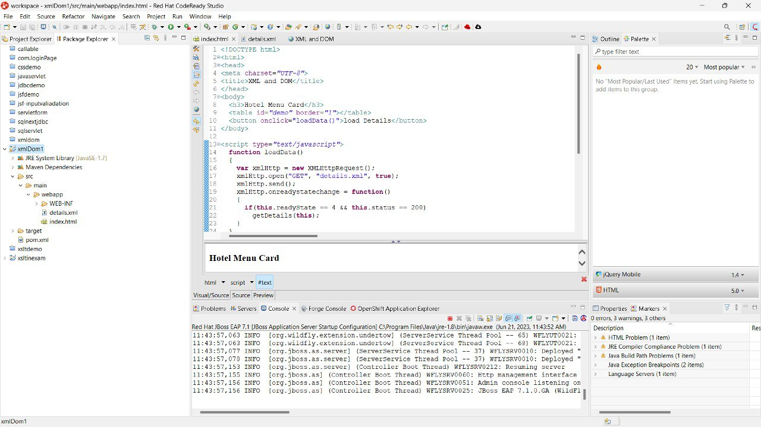

**Index.html**

<!DOCTYPE html>

<html>

<head>

<meta charset=*"UTF-8"*>

<title>XML & DOM</title>

</head>

<body>

<h3>Hotel Menu Card</h3>

<table id=*"demo"* border=*"1"*></table>

<button onclick="loadData()">load Details</button>

</body>

<script type=*"text/javascript"*>

**function** loadData()

{

**var** xmlHttp = **new** XMLHttpRequest();

xmlHttp.open("GET", "det.xml", **true**);

xmlHttp.send();

xmlHttp.onreadystatechange = **function**()

{

**if**(**this**.readyState == 4 && **this**.status == 200)

getDetails(**this**);

}

}

**function** getDetails(response)

{

**var** xmlDoc = response.responseXML;

**var** X = xmlDoc.getElementsByTagName("student");

**var** table = "<tr> <th>Dish NAME</th> <th>price</th><th>discount</th><th>calories</th> </tr>";

**for**(**var** i=0; i<X.length; i++)

{

table += "<tr> <td>"+ X[i].getElementsByTagName("name")[0].childNodes[0].nodeValue +"</td> <td>"+ X[i].getElementsByTagName("price")[0].childNodes[0].nodeValue +X[i].getElementsByTagName("discount")[0].childNodes[0].nodeValue + X[i].getElementsByTagName("calories")[0].childNodes[0].nodeValue +"</td> </tr>";

}

document.getElementById("demo").innerHTML = table;

}

</script>

</html>

**Details.xml**

<?xml version=*"1.0"* encoding=*"UTF-8"*?>

<department>

<student>

<name>Fried Rice</name>

<price>100</price>

<discount>10%</discount>

<calories>150cal</calories>

</student>

<student>

<name>Egg Fried Rice</name>

<price>150</price>

<discount>15%</discount>

<calories>2000cal</calories>

</student>

<student>

<name>Chicken Manchuriya</name>

<price>200</price>

<discount>15%</discount>

<calories>170cal</calories>

</student>

<student>

<name>Sandwich</name>

<price>150</price>

<discount>20%</discount>

<calories>80cal</calories>

</student>

</department>